**COUNTY COMMISSIONERS:**

Jamie Carpenter

David Strait

Jedd Schola

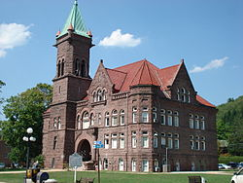

**ADDRESS:**

26 North Main

Philippi, West Virginia 26416

**PHONE:** 304-457-4339

**FAX:** 304-457-5472

County Commission ofBarbour County, West Virginia

November 17, 2023

Arch Resources, Leer South Mining Complex

Attn: Larry Gore

21550 Barbour County Highway

Philippi, WV 26416

Dear Mr. Gore,

The Barbour County Commission is pleased to announce that Arch Resources, Leer South Mining Complex is the 2023 recipient of the *Emergency and Crisis Management Exemplary Community Award*. Through this award, the Barbour County Commission is recognizing the work being done in Barbour County to prevent, prepare for, respond to and recover from emergencies and disasters. This prestigious recognition is for exceptional service and achievement in emergency crisis preparedness. Your progressive planning, emergency preparedness exercises and implementation of mock drills with community collaboration is making way for your emergency plans to be flawless and effective. The County Commission would like to thank you for your commitment to our community and creating a precedence in emergency preparedness.

The Barbour County Commission is cordially inviting representatives from Arch Resources, Leer South Mining Complex to attend their County Commission meeting on **December 4, 2023 at 5:00pm** to accept the annual Emergency and Crisis Management Exemplary Community Award. Please confirm your attendance to [sfrey@barbourcountywv.org](mailto:sfrey@barbourcountywv.org).

Congratulations!

Sincerely,

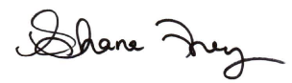

Shana Frey

County Administrator

Barbour County Commission